

INDIAN SCHOOL NIZWA

INFORMATICS PRACTICES PROJECT

Project Title: CDA: Covid Data Analyzer

Submitted By:

Nikhil Shibu

Elgin Siju

Vishakh Nair

CONTENT

* CERTIFICATE
* ACKNOWLEDGEMENT
* SYNOPSIS
* CSV FILE
* SOURCE CODE
* OUTPUT
* BIBLIOGRAPHY

Name of Institution:

CERTIFICATE

This is to certify that of class , has satisfactorily completed the project of information practices.

Sign of Internal Sign of External

Examiner: Examiner:

______________ _____________

ACKNOWLEDGEMENT

I would like to express my special thanks of gratitude to my teacher Mrs. Cini who gave me the golden opportunity to do this project. This also helped me to understand many new things while doing the project. I am really thankful to my team mates who have helped me complete this project. My sincere thanks to all.

SYNOPSIS

This pandemic has created a lot panic and distress among the individuals as well as with the health department. So that’s why we have designed the Mini - Version of the project titled “CDA: Covid Data Analyzer” which controls and showcases data to an individual in an understanding manner. This project is designed and Coded in Python and the data is entered in MS Excel.

The csv file is created in Excel by collecting data from world meters website. The project has five parts: Fetch Data, Dataframe statistics, Display Records, Data Visualization and Data Analytics.

**Fetch Data** displays the csv file with date as indexes and Total Deaths, Active cases, Recoveries, Confirmed cases etc. as column names. **Dataframe** Statistics command displays a menu which includes six different commands such as displaying column names, indexes, Shape, Dimension, Size and Data types of all columns. **Display Records** contain four specific commands like Top 5 Records, Bottom 5 Records and specific number of records from top and from bottom. **Data Visualization** includes three types of plots such as line plot (No. of active cases), Horizontal Bar chart (No. of confirmed cases), Vertical Bar Chart (No. of Deaths). **Data Analytics** has eight distinct commands to find the date on which the maximum & minimum number of active cases, recoveries, confirmed cases and deaths were observed.

This project has been made to extract the data from Excel and display to the user by considering his/her needs. It can display any covid19 related data as per the user’s commands. The project allows the user to Fetch Data, to get a clear idea about the Data frame Statistics, to access the records, to get a detailed data visualization and to have a comprehensive data analytics.

This helps the individual/ health departments to get an overall report which will help them to take the necessary preventive measures.

The project’s user friendly interface helps the solitary save time and money and the project can be altered in accordance with future requirements of the organization.

CSV FILE: COVID19.csv

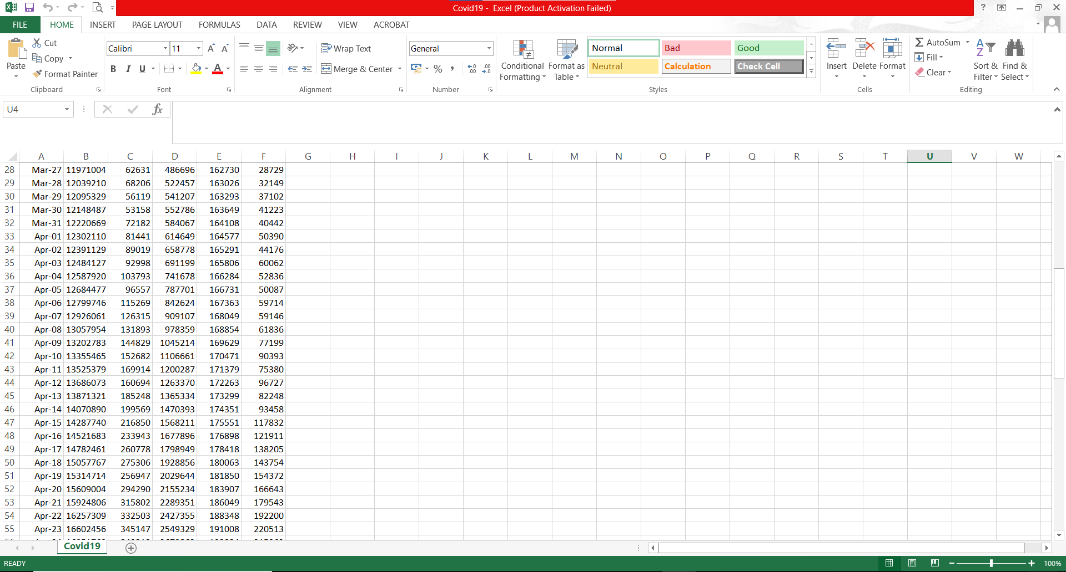

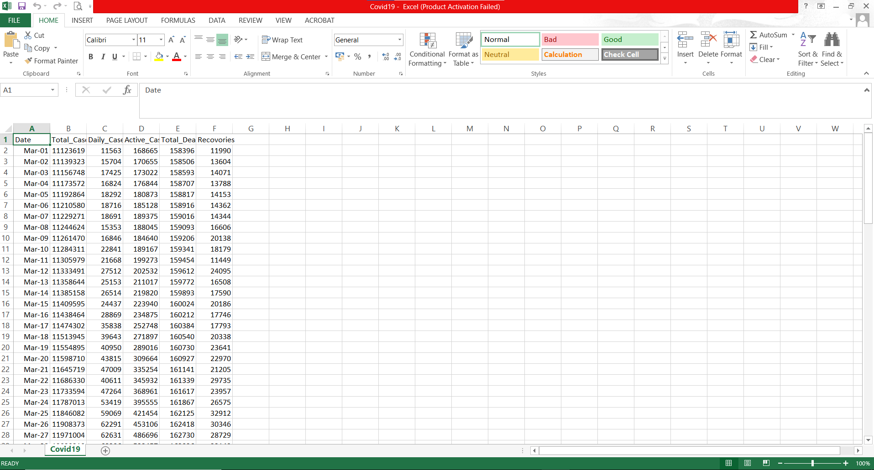

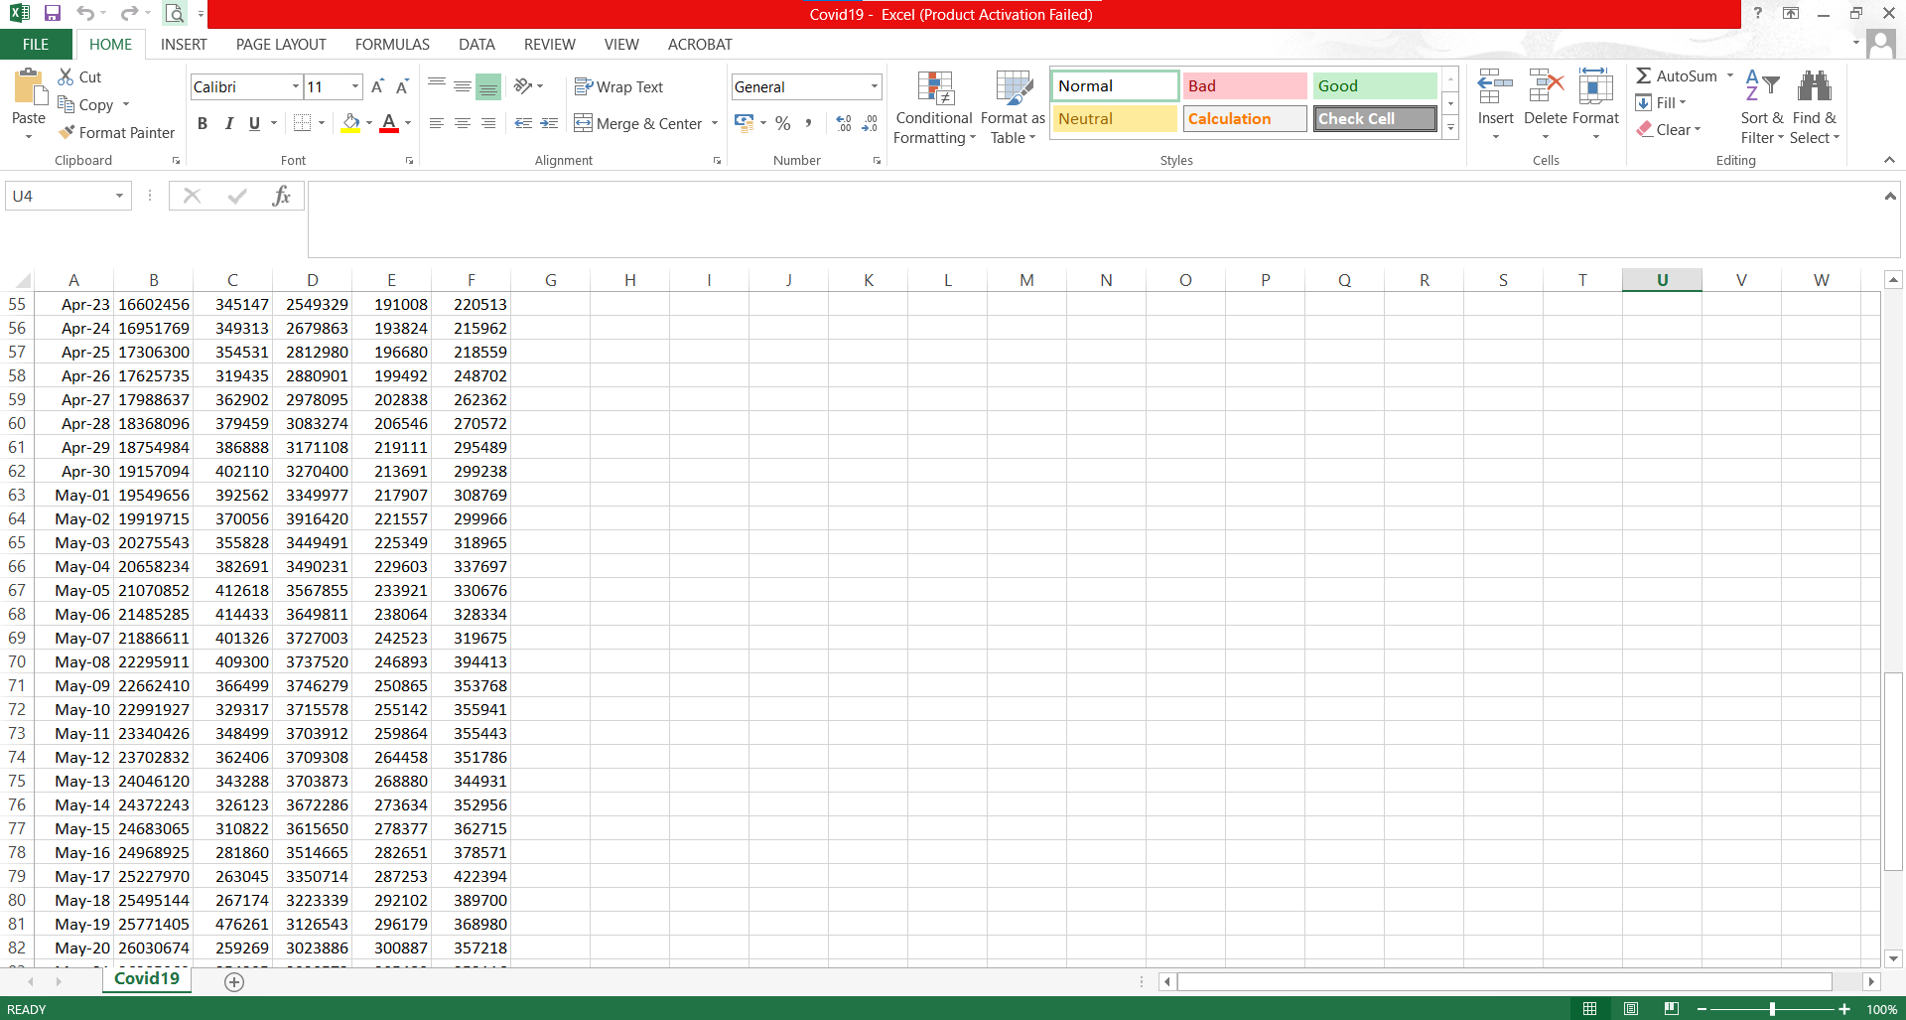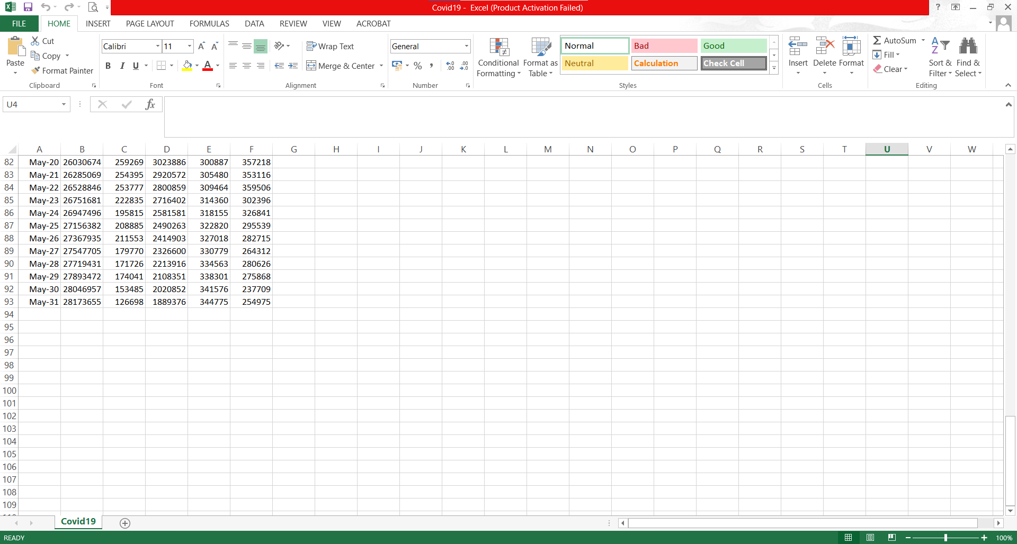

SOURCE CODE

import pandas as pd

import matplotlib.pyplot as plt

df=pd.read_csv("F:\\Python programs\\IP Project\\Covid19.csv",index_col=0)

cov=pd.DataFrame(df,columns=["Total_Cases","Daily_Cases","Active_Cases","Total_Death","Recovories"])

ch='y'

while ch=='y'or ch=='Y':

print("Main Menu")

print("1.Fetch Data")

print("2.Dataframe Statistics")

print("3.Display Records")

print("4.Data Visualization")

print("5.Data analytics")

print("6.Exit")

ch1=int(input("Enter your choice:"))

if ch1==1:

print("DISPLAYING DAILY SPIKES IN COVID CASES IN THE MONTH OF MARCH,APRIL AND MAY 2021")

print("=============================")

print(cov)

elif ch1==2:

while(True):

print("Dataframe Statistics Menu")

print("1.Display all column names")

print("2.Display the indexes")

print("3.Display the shape")

print("4.Display the dimension")

print("5.Display the data types of all columns")

print("6.Display the size")

print("7.Exit")

ch2=int(input("Enter Choise:"))

if ch2==1:

print(cov.columns)

elif ch2==2:

print(cov.index)

elif ch2==3:

print(cov.shape)

elif ch2==4:

print(cov.ndim)

elif ch2==5:

print(cov.dtypes)

elif ch2==6:

print(cov.size)

elif ch2==7:

break

elif ch1==3:

while(True):

print("Display Records Menu")

print("1.Top 5 Records")

print("2.Bottom 5 Records")

print("3.Specific number of records from the top")

print("4.Specific number of records from the bottom")

print("5.Exit")

ch3=int(input("Enter Choice:"))

if ch3==1:

print(cov.head())

elif ch3==2:

print(cov.tail())

elif ch3==3:

n=int(input("Enter how many records you want to display from the top:"))

print(cov.head(n))

elif ch3==4:

n=int(input("Enter how many records you want to display from the bottom:"))

print(cov.tail(n))

elif ch3==5:

break

elif ch1==4:

while(True):

print("Data Visualization Menu")

print("1.Line Plot --> No. of active cases")

print("2.Horizontal Bar Plot --> No. of confirmed cases")

print("3.Vertical bar plot --> No.of deaths")

print("4.Exit")

ch5=int(input("Enter Choice:"))

if ch5==1:

x=cov.index

y=cov['Active_Cases']

plt.plot(x,y)

plt.title("No.of active cases")

plt.xlabel("Date")

plt.ylabel("Active Cases")

plt.show()

elif ch5==2:

plt.barh(cov.index,cov.Total_Cases)

plt.title("No.of confirmed cases")

plt.xlabel("Confirmed Cases")

plt.ylabel("Date")

plt.show()

elif ch5==3:

plt.bar(cov.index,cov.Total_Death)

plt.title("No.of Deaths")

plt.xlabel("Date")

plt.ylabel("Deaths")

plt.show()

elif ch5==4:

break

elif ch1==5:

while(True):

print("Data Analytics Menu")

print("1.Date on which maximum active cases were observed")

print("2.Date on which minimum active cases were observed")

print("3.Date on which maximum recovered cases were observed")

print("4.Date on which minimum recovered cases were observed")

print("5.Date on which maximum confirmed cases were observed")

print("6.Date on which minimum confirmed cases were observed")

print("7.Date on which maximum deaths were observed")

print("8.Date on which minimum deaths were observed")

print("9.Exit")

ch6=int(input("Enter Choice:"))

if ch6==1:

m=cov['Active_Cases'].max()

s=cov.loc[cov.Active_Cases==m]

print("Date on which maximum active cases were observed--",m,"is\n",s.index)

elif ch6==2:

m=cov['Active_Cases'].min()

s=cov.loc[cov.Active_Cases==m]

print("Date on which minimum active cases were observed--",m,"is\n",s.index)

elif ch6==3:

m=cov['Recovories'].max()

s=cov.loc[cov.Recovories==m]

print("Date on which maximum recovered cases were observed--",m,"is\n",s.index)

elif ch6==4:

m=cov['Recovories'].min()

s=cov.loc[cov.Recovories==m]

print("Date on which minimum recovered cases were observed--",m,"is\n",s.index)

elif ch6==5:

m=cov['Total_Cases'].max()

s=cov.loc[cov.Total_Cases==m]

print("Date on which maximum confirmed cases were observed--",m,"is\n",s.index)

elif ch6==6:

m=cov['Total_Cases'].min()

s=cov.loc[cov.Total_Cases==m]

print("Date on which minimum confirmed cases were observed--",m,"is\n",s.index)

elif ch6==7:

m=cov['Total_Death'].max()

s=cov.loc[cov.Total_Death==m]

print("Date on which maximum deaths were observed--",m,"is\n",s.index)

elif ch6==8:

m=cov['Total_Death'].min()

s=cov.loc [cov.Total_Death==m]

print("Date on which minimum deaths were observed--",m,"is\n",s.index)

elif ch6==9:

break

elif ch1==6:

break

OUTPUT SCREEN

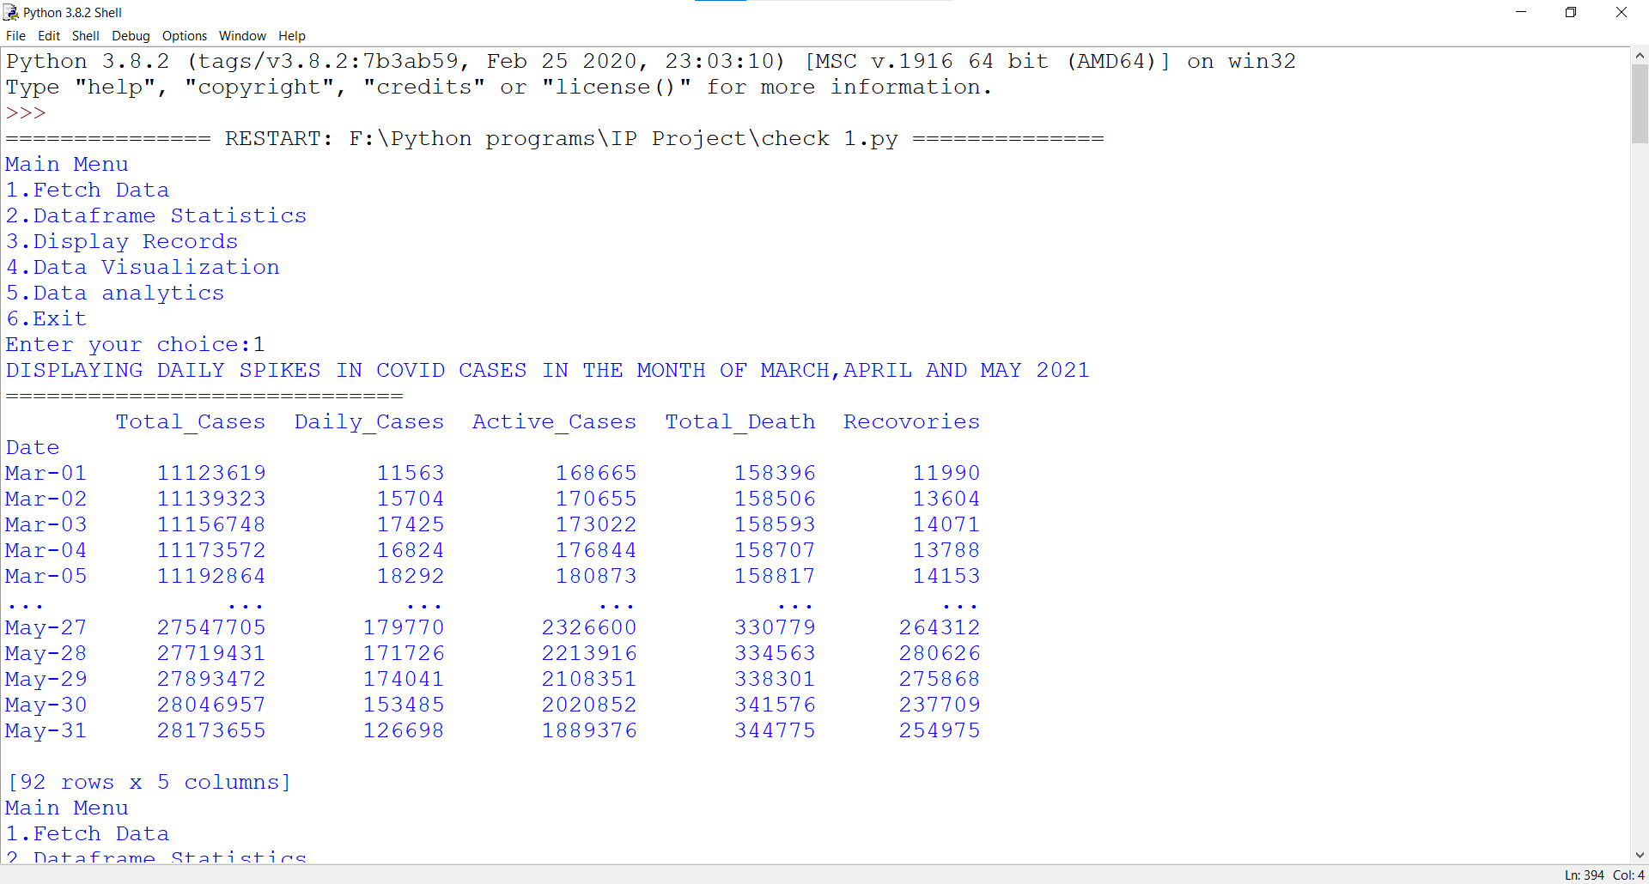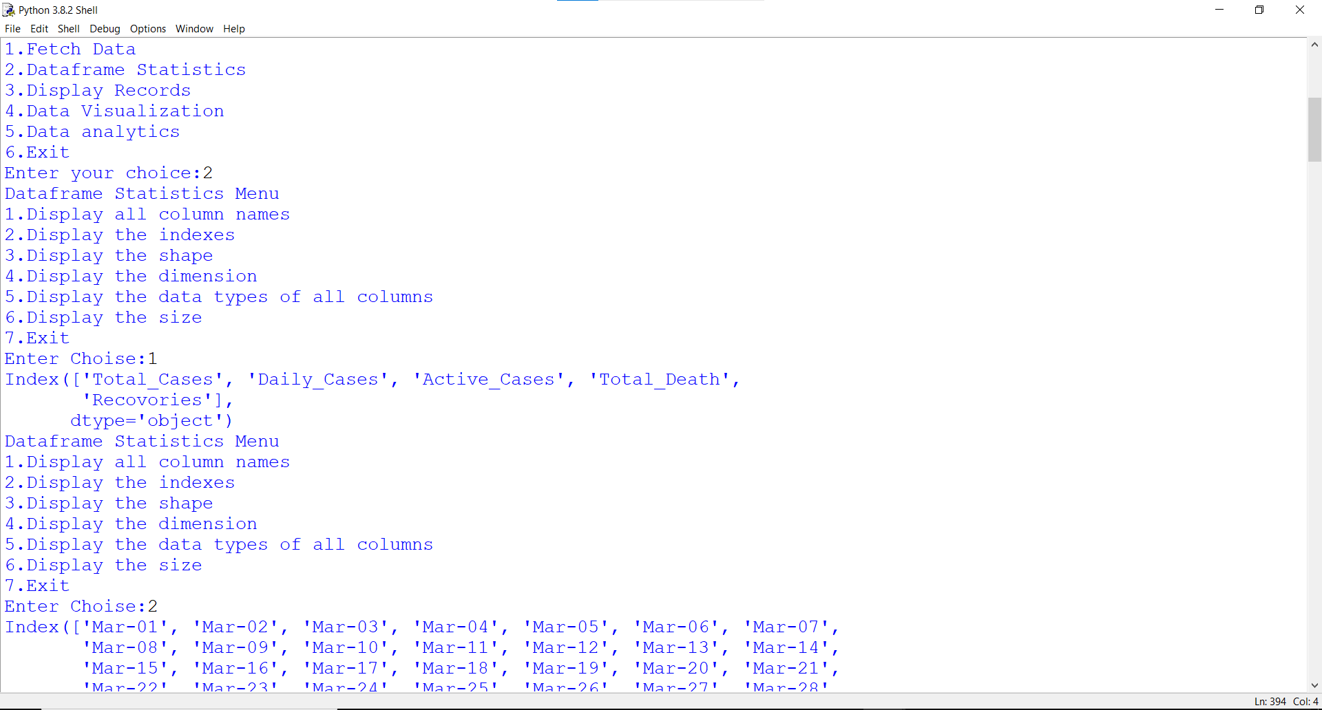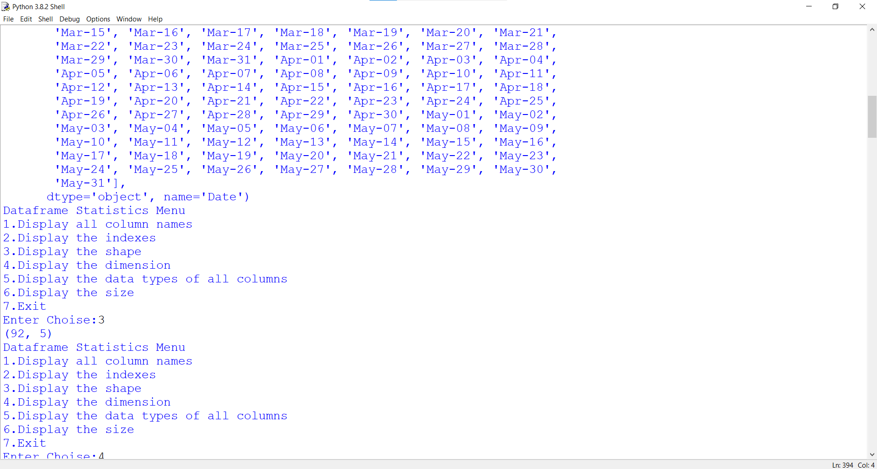

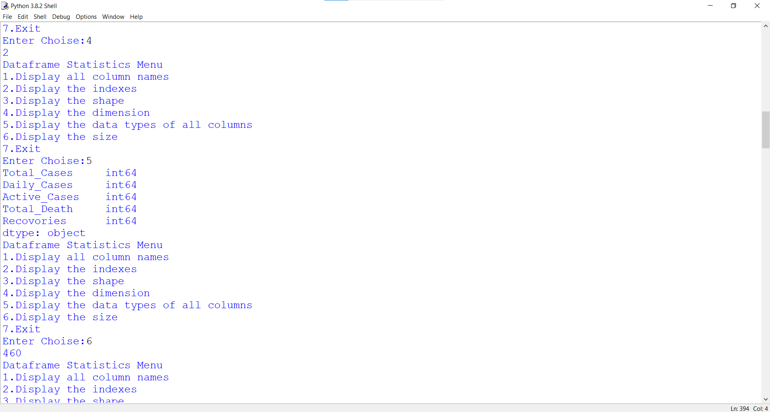

.

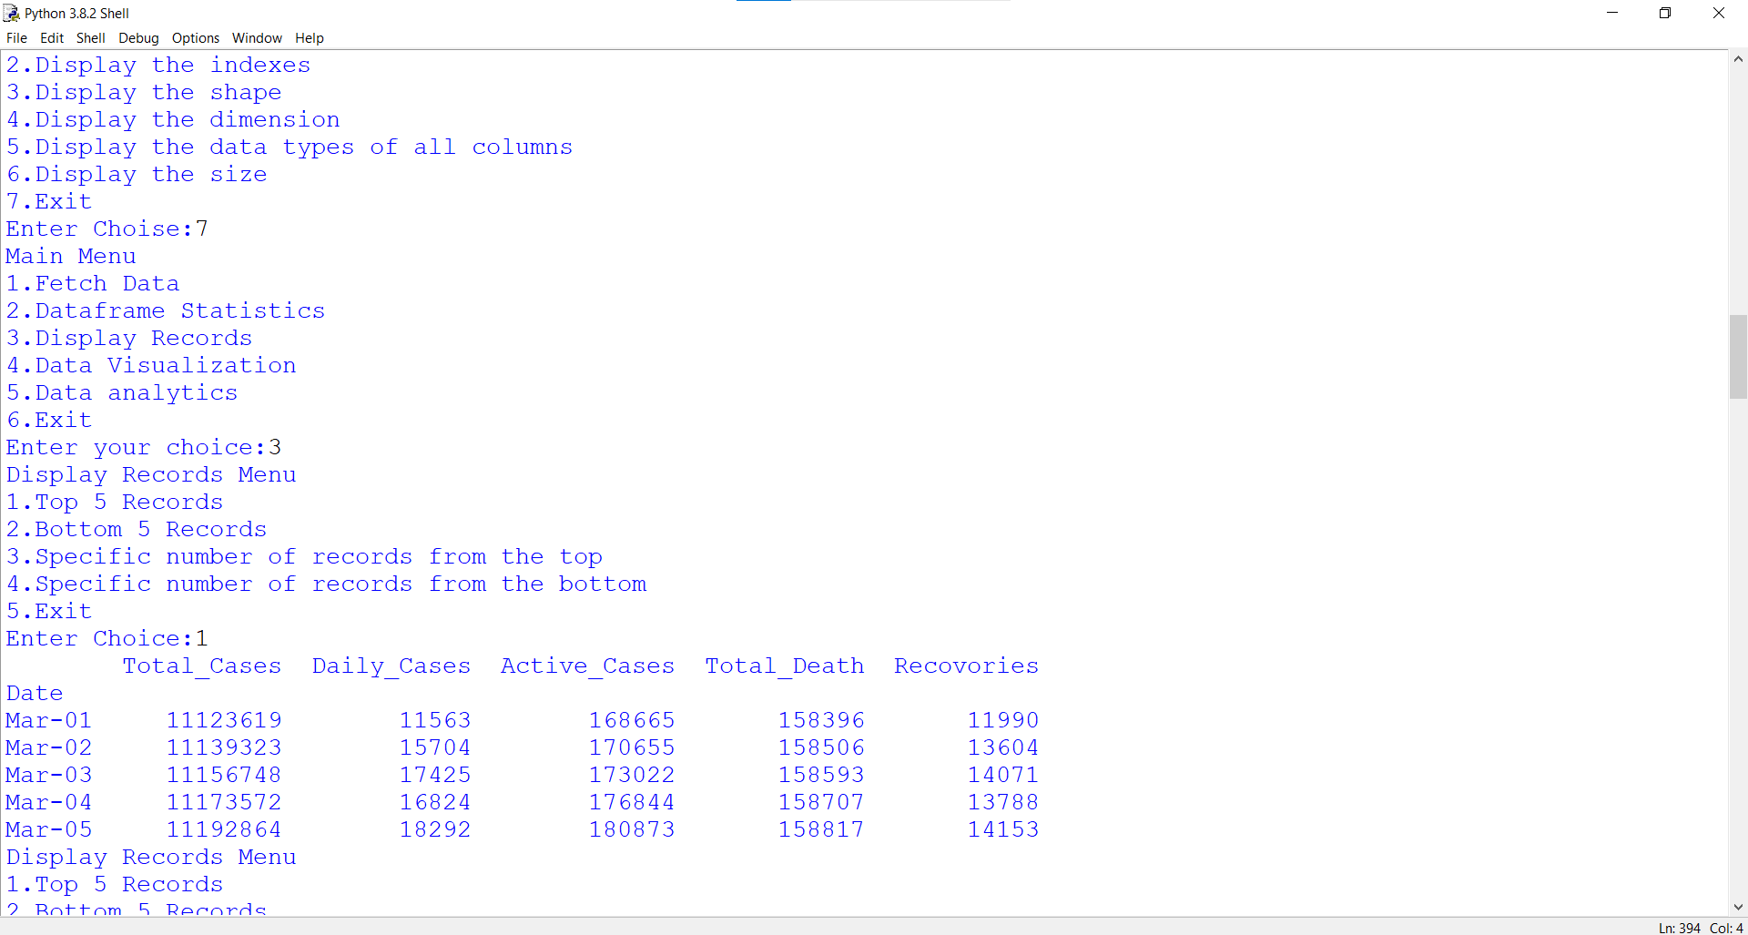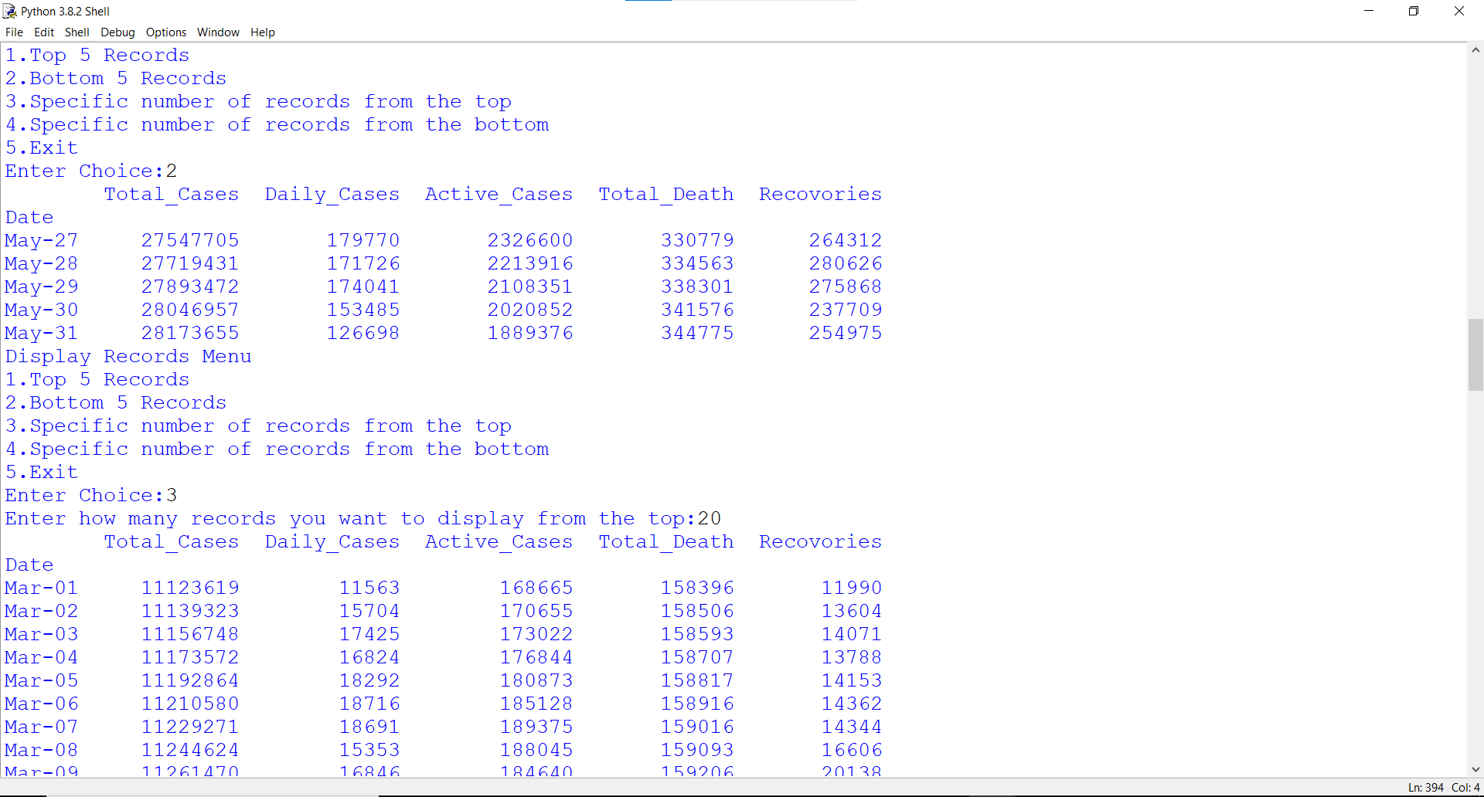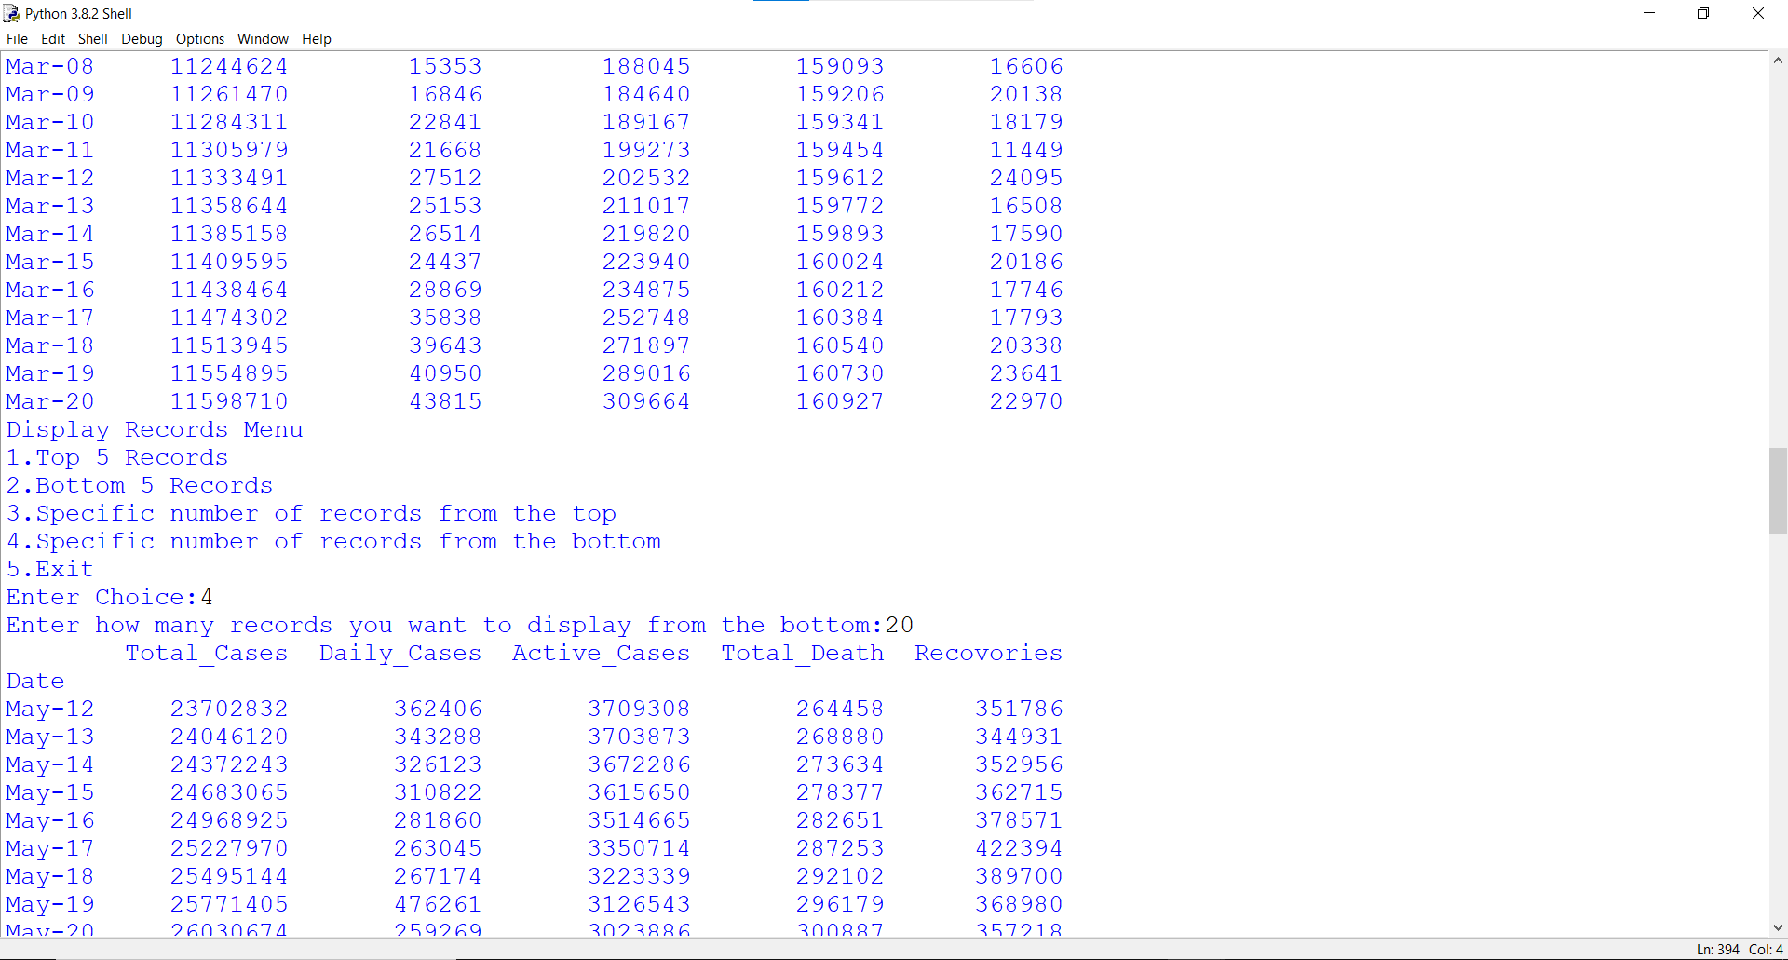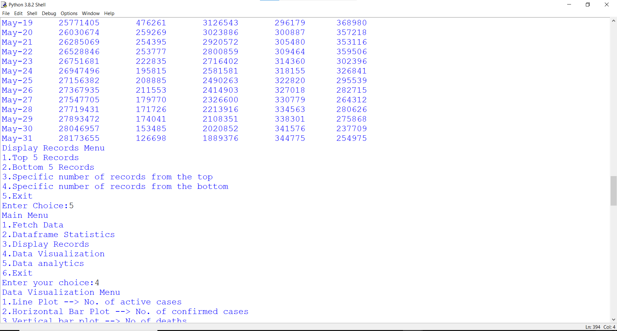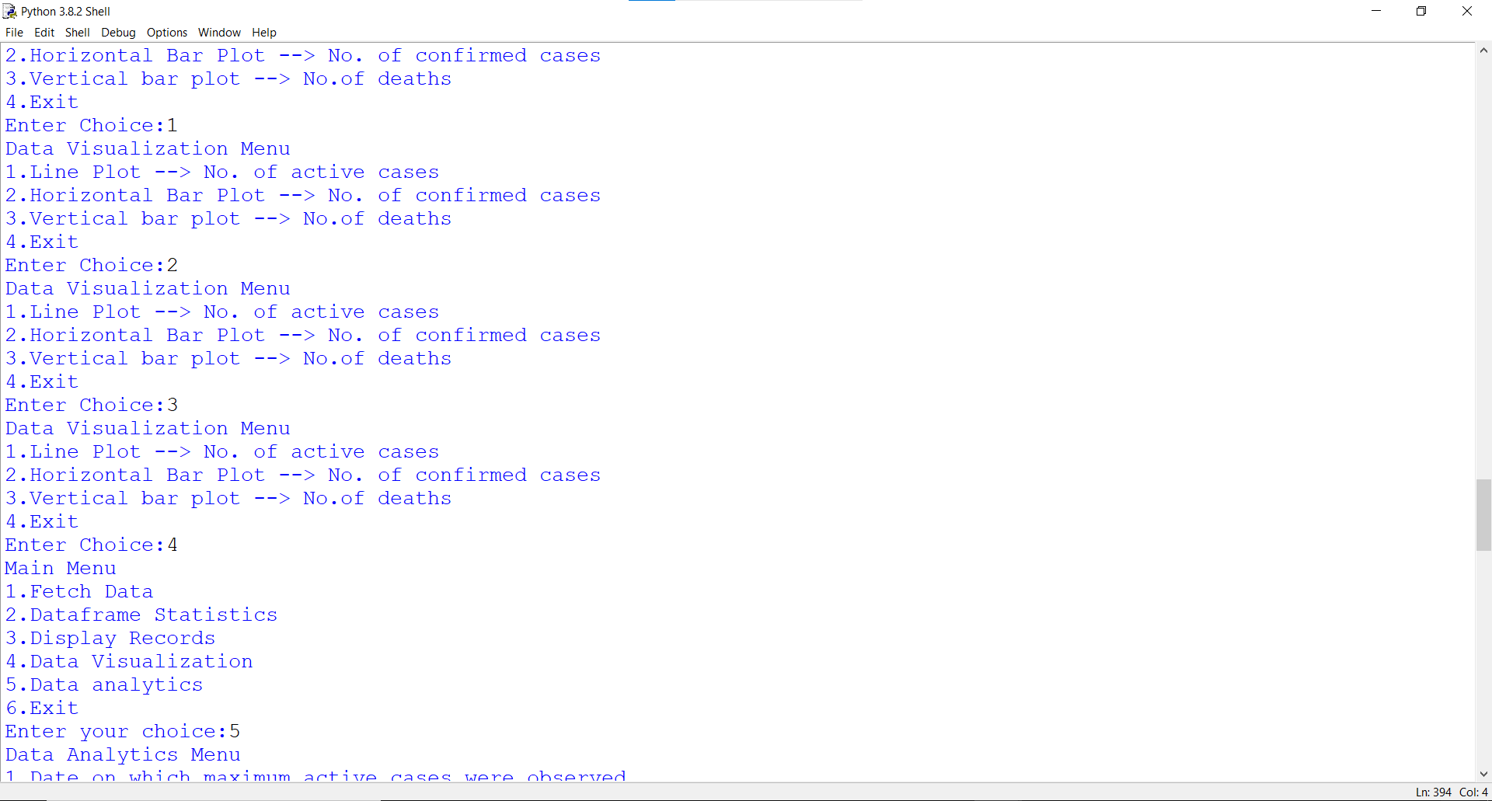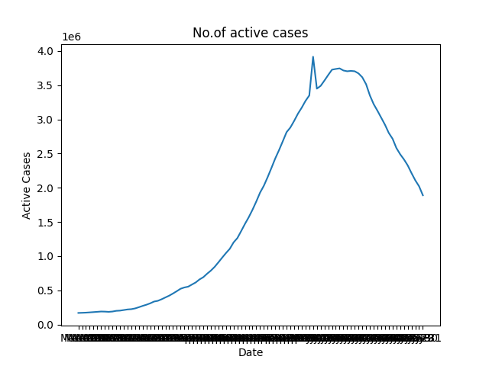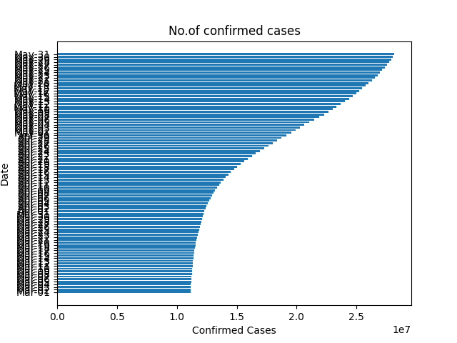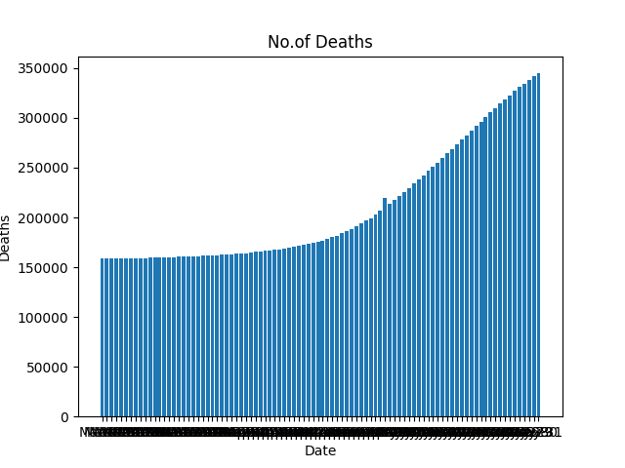

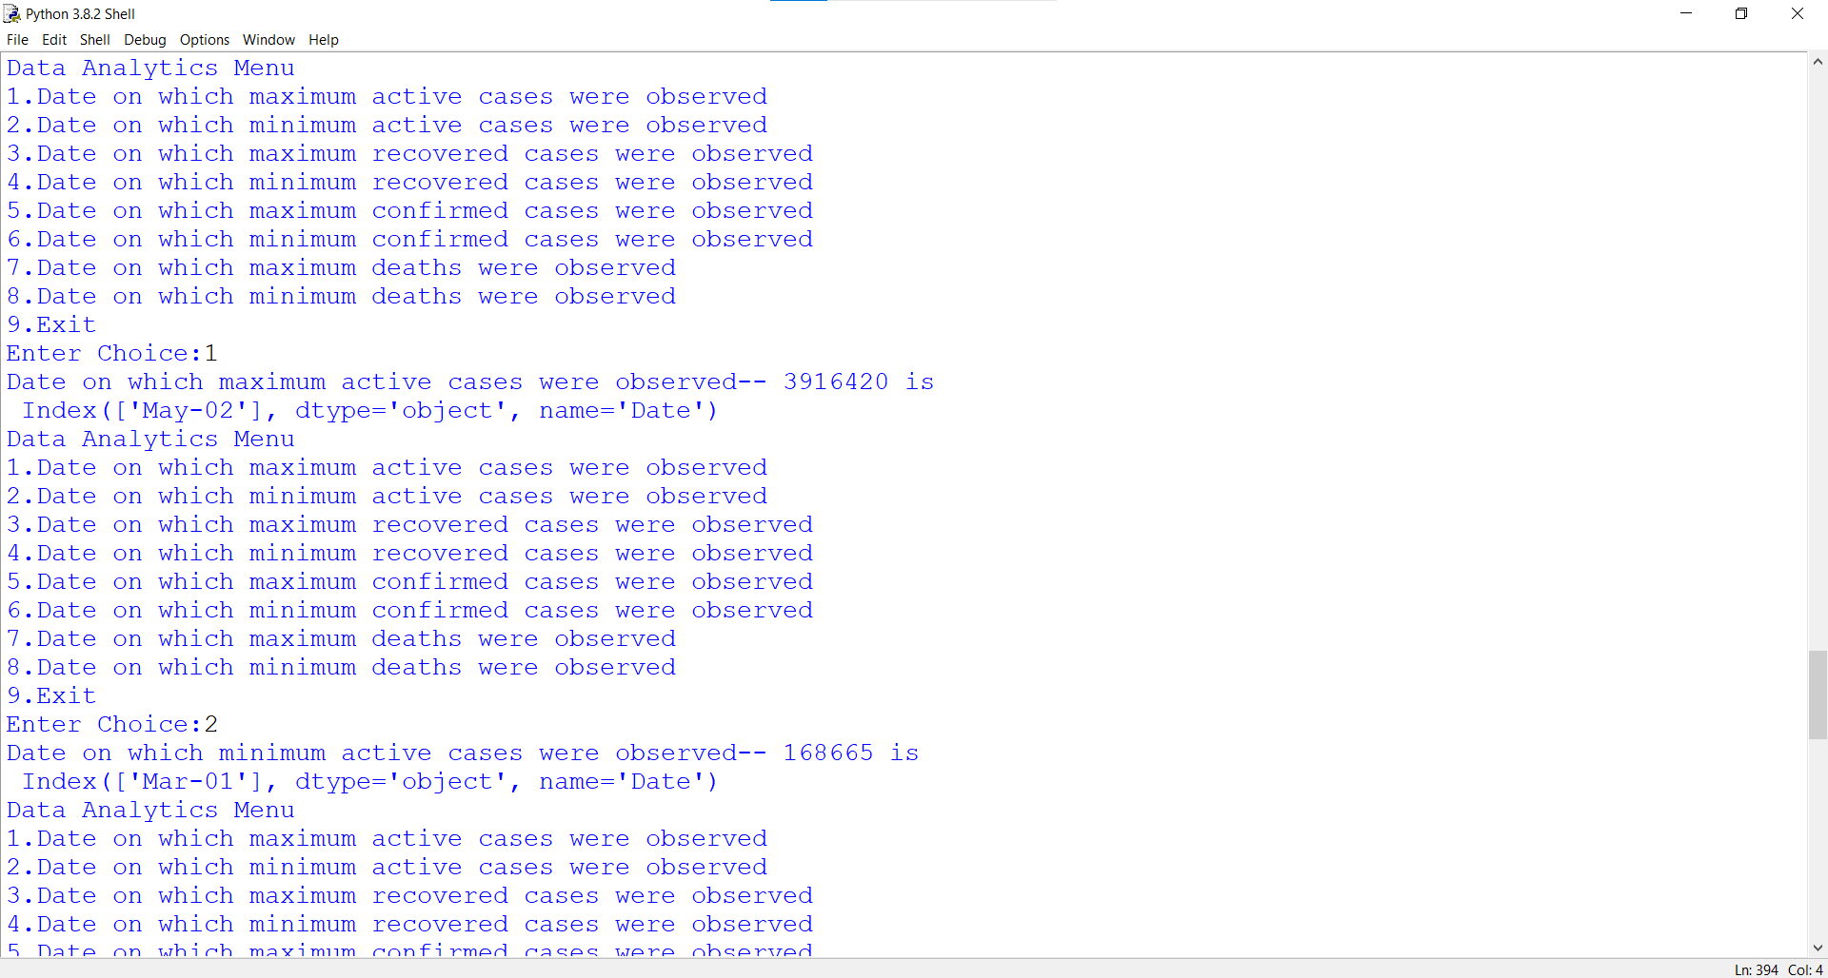

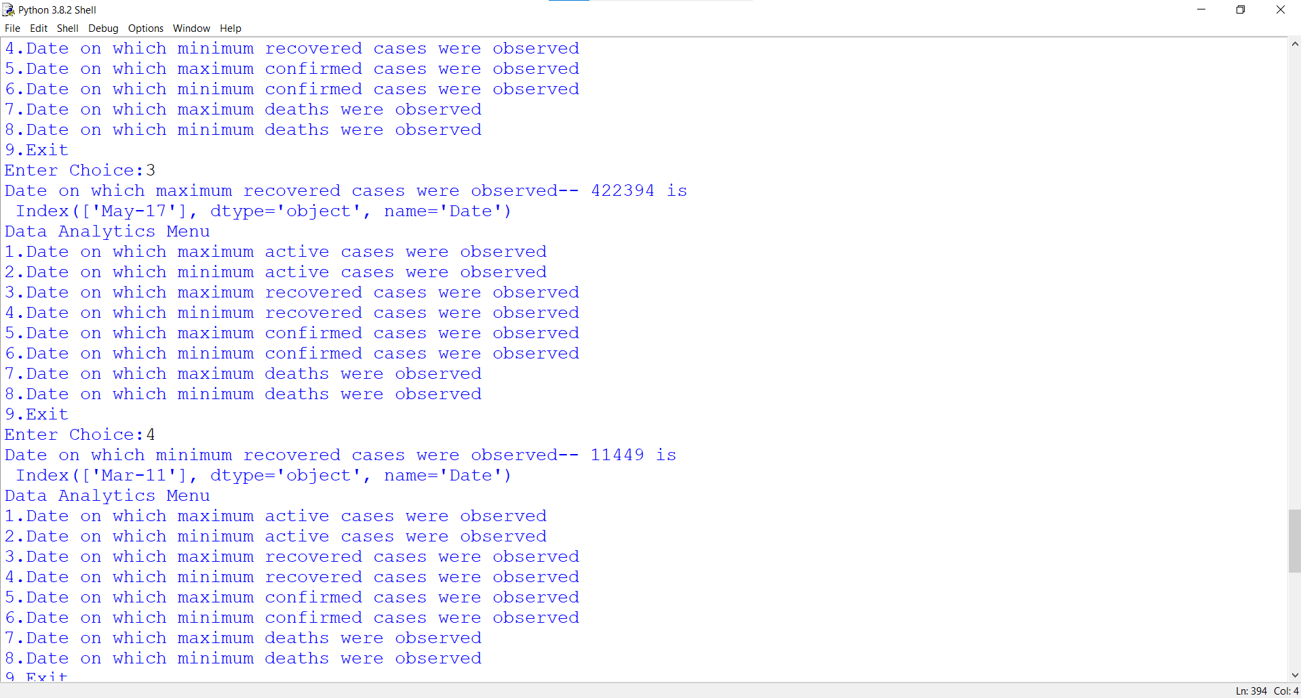

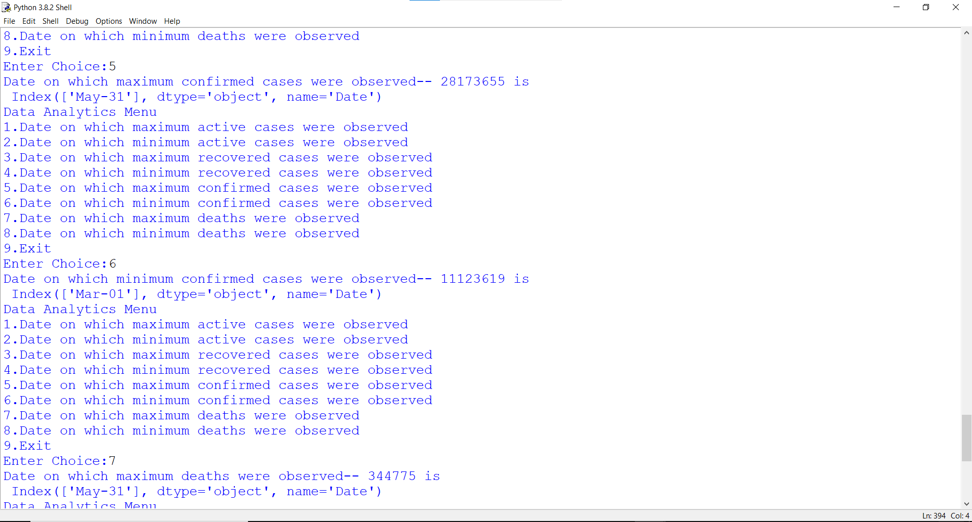

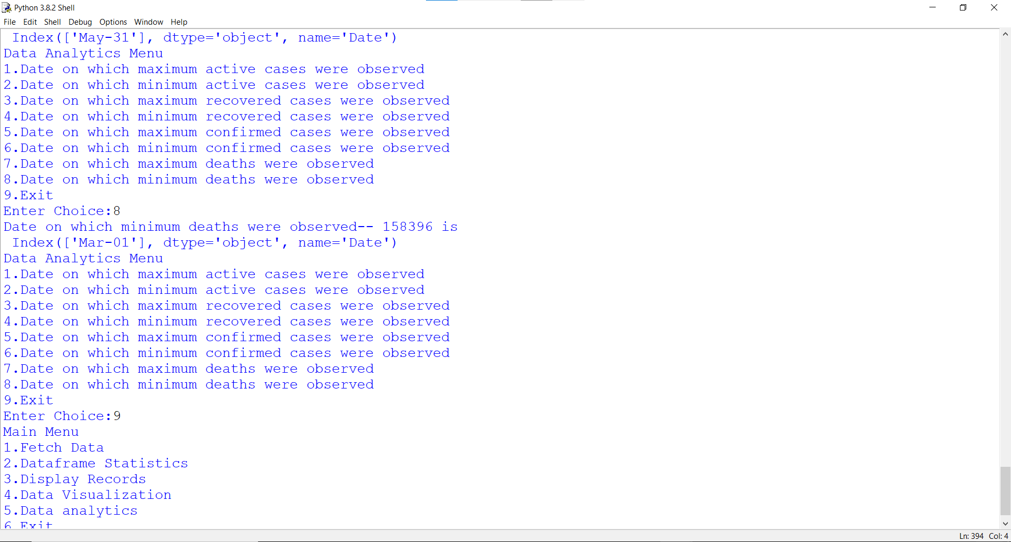

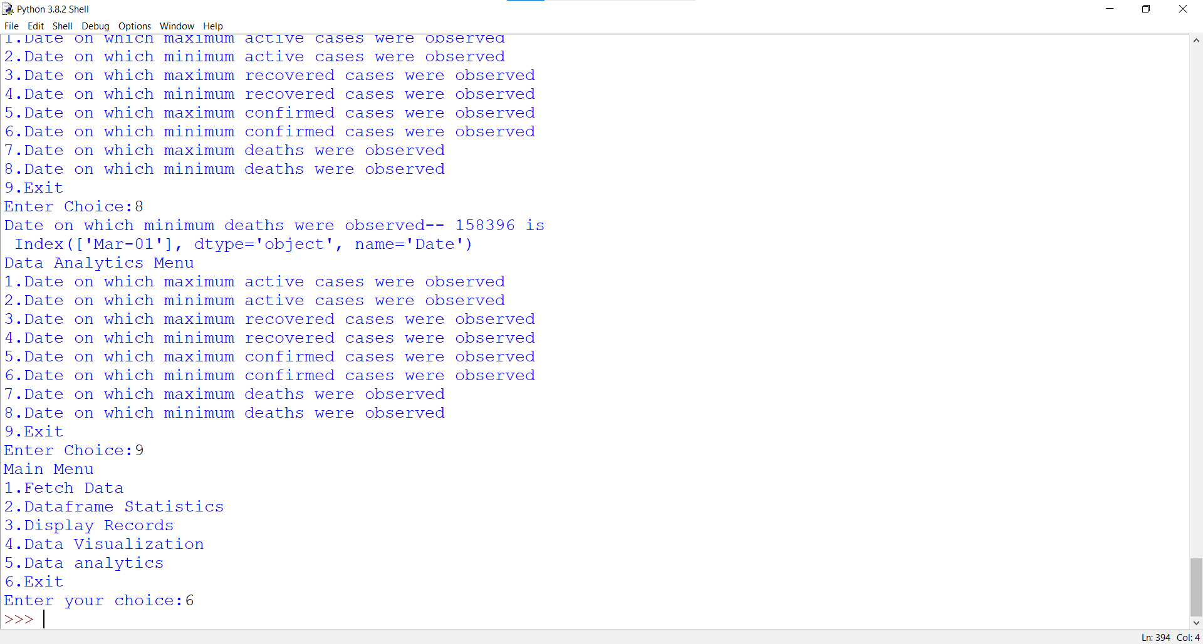

BIBLIOGRAPHY

1. Informatics Practices By – Sumita Arora
2. Informatics Practices with Python By – Preeti Arora
3. Class Notes
4. YouTube Reference : <https://youtu.be/RShSw9DyIGw>
5. Covid19 Data : <https://www.worldometers.info/coronavirus/country/india/>